Supplemental Material
Short-term association between air pollution and infectious disease spectrum in Shanghai, China: a time-series study from 2013 to 2019
Yihan Lin^{1#}, Hao Meng^{2#}, Yong He², Wenzhuo Liang¹, Yiran Niu¹, Zhenliang Liu¹, Ziying Wang², Yuan Lei¹, Yangyang Tian¹, Shiyang Chang¹*
- Department of Histology and Embryology, College of Basic Medical, Hebei Medical University, Shijiazhuang 050017, China.
- Department of Pathogenic Biology, College of Basic Medicine, Hebei Medical University, Shijiazhuang, Hebei, China.
Address correspondence to Shiyang Chang, Department of Histology and Embryology, College of Basic Medical, Hebei Medical University, Shijiazhuang 050017, China. Tel./Fax: +86-0311-86266084. E-mail: changshiyangie@163.com 18901410@hebmu.edu.cn.
#These authors contributed equally to this work as co-first authors.
*Corresponding author.
Conflicts of Interest: The authors declare no actual or potential conflicts of interest.
Funding: The authors declare that no funds, grants, or other support were received during the preparation of this manuscript.
List of Contents
Figure S1. Choices of methodology and parameter for modeling seasonality and long-time trend.
Figure S2. Time-series plots of different categories of infectious disease during 2013-2019.
Figure S3. Time-series plots of air pollutants and weather variables during 2013-2019.
Figure S4. Spearman correlation matrix of air pollutants and weather variables during 2013-2019.
Table S1. Association between monthly air pollutants and specific infectious diseases in the double-pollutant DLM model.
Table S2. Relative risk (and 95% CIs) of monthly number of infectious diseases per unit increase in ozone in single-pollutant model.
Table S3. Relative risk (and 95% CIs) of monthly number of infectious diseases per unit increase in air pollutants in the double-pollutant model.

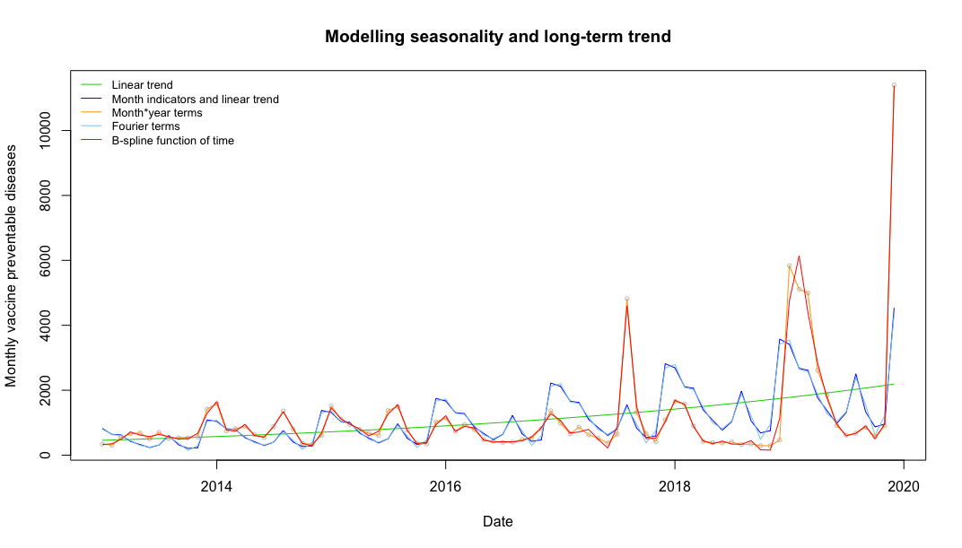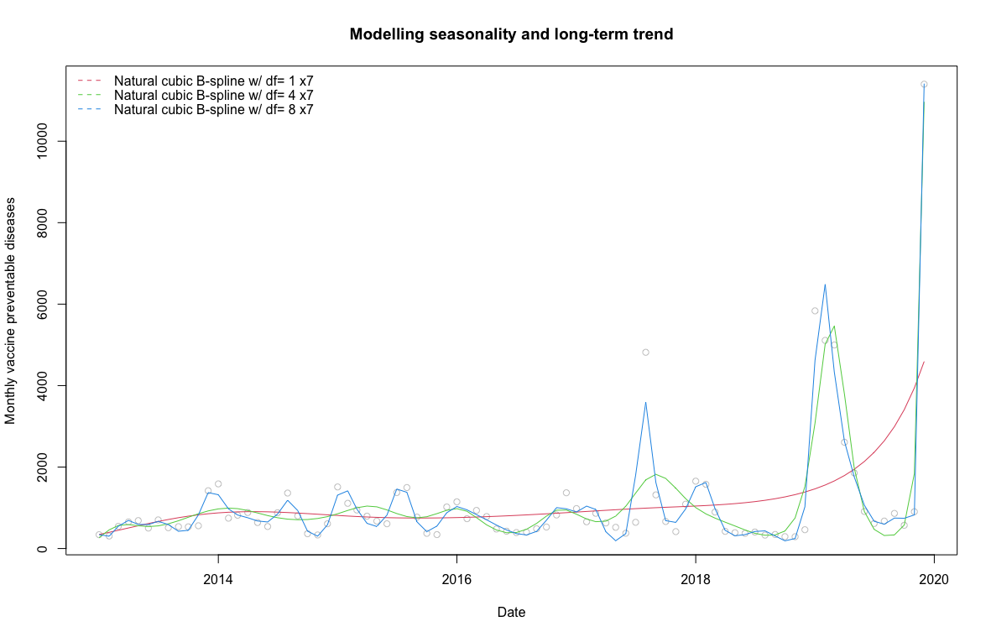Fig S1. Choices of methodology and parameter for modeling seasonality and long-time trend.
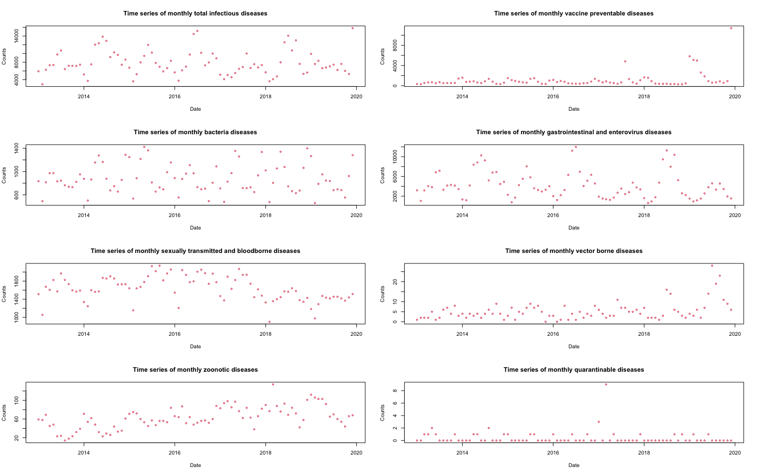Fig S2. Time-series plots of different categories of infectious disease during 2013-2019.
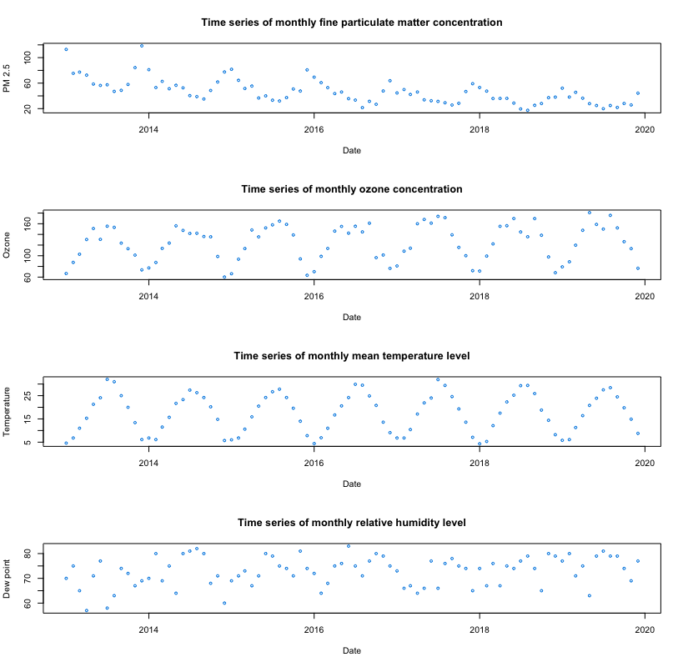
Fig S3. Time-series plots of air pollutants and weather variables during 2013-2019.
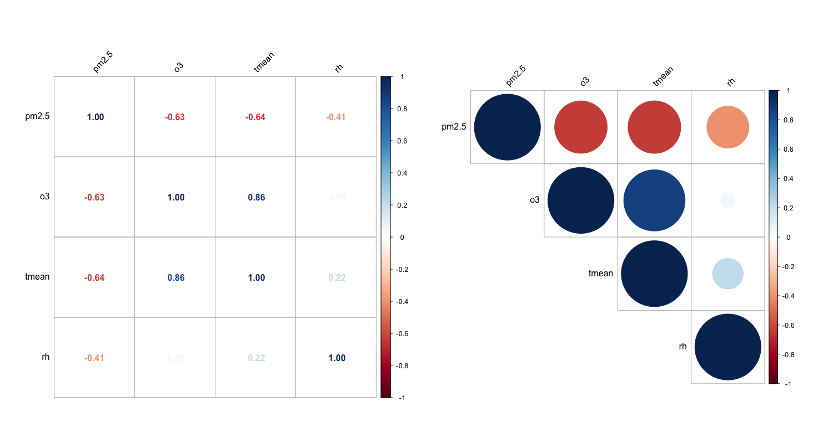 Fig S4. Spearman correlation matrix of air pollutants and weather variables during 2013-2019.
Table S1. Association between monthly air pollutants and specific infectious diseases in the double-pollutant DLM model.
 | PM_{2.5} |  |  |  | Ozone
 | Lag0 | Lag1 | Lag2 | Net effect | Lag0 | Lag1 | Lag2 | Net effect
Vaccine preventable diseases
SI | 1.21 (0.29, 5.10) | 0.74 (0.07, 7.49) | 1.04 (0.30, 3.59) | 0.94 (0.01, 127.91) | 1.36 (0.71, 2.58) | 2.59 (1.03, 6.55) | 1.68 (1.00, 2.80) | 5.89 (0.77, 44.96)
Mumps | 0.90 (0.54, 1.48) | 0.85 (0.38, 1.93) | 0.91 (0.58, 1.43) | 0.70 (0.12, 3.92) | 1.28 (1.02, 1.62) | 1.63 (1.19, 2.23) | 1.39 (1.13, 1.70) | 2.90 (1.39, 6.02)
Bacteria diseases
TB | 0.77 (0.58, 1.02) | 0.67 (0.42, 1.05) | 0.77 (0.60, 0.99) | 0.39 (0.15, 1.04) | 1.15 (0.94, 1.42) | 1.18 (0.89, 1.56) | 1.11 (0.92, 1.32) | 1.50 (0.78, 2.88)
SF | 0.81 (0.44, 1.51) | 0.65 (0.23, 1.81) | 0.69 (0.40, 1.20) | 0.37 (0.04, 3.15) | 1.59 (1.10, 2.31) | 2.15 (1.27, 3.65) | 1.68 (1.22, 2.33) | 5.77 ( 1.75, 19.05)
Gastrointestinal and enterovirus diseases
ID | 0.73 (0.50, 1.06) | 0.57 (0.31, 1.05) | 0.72 (0.52, 1.02) | 0.30 (0.08, 1.09) | 0.88 (0.68, 1.15) | 0.94 (0.66, 1.34) | 0.94 (0.75, 1.18) | 0.78 (0.34, 1.77)
HFMD | 0.78 (0.43, 1.43) | 0.52 (0.20, 1.33) | 0.71 (0.42, 1.19) | 0.29 (0.04, 2.16) | 1.15 (0.84, 1.58) | 1.38 (0.90, 2.11) | 1.23 (0.93, 1.63) | 1.95 (0.72, 5.27)
Sexually transmitted and bloodborne diseases
Syphilis | 0.81 (0.68, 0.96) | 0.69 (0.52, 0.92) | 0.79 (0.68, 0.92) | 0.44 (0.24, 0.80) | 1.08 (0.93, 1.24) | 1.13 (0.93, 1.37) | 1.08 (0.96, 1.23) | 1.32 (0.84, 2.07)
Gonorrhea | 0.80 (0.66, 0.96) | 0.69 (0.51, 0.93) | 0.76 (0.64, 0.89) | 0.41 (0.22, 0.78) | 1.20 (1.05, 1.38) | 1.31 (1.09, 1.56) | 1.20 (1.08, 1.34) | 1.89 (1.25, 2.86)
Zoonotic diseases
Hepatitis E | 0.89 (0.55, 1.43) | 0.80 (0.36, 1.78) | 0.86 (0.56, 1.32) | 0.61 (0.11, 3.25) | 1.06 (0.78, 1.43) | 1.15 (0.76, 1.76) | 1.09 (0.83, 1.42) | 1.32 (0.50, 3.47)
Notes: SI: Seasonal influenza; TB: Tuberculosis; SF: Scarlet fever; ID: Infectious diarrhea; HFMD: Hand, foot, and mouth disease.

Table S2. Relative risk (and 95% CIs) of monthly number of infectious diseases per unit increase in ozone in single-pollutant model.
 |  | Total |  | Vaccine preventable |  | Bacteria |  | Gastrointestinal and enterovirus | Sexually transmitted and bloodborne |  | Zoonotic
PM_{2.5} | Single Lag Model
 | Lag0 | 1.10 (1.02, 1.19) | 1.29 (1.10, 1.52) |  | 1.04 (0.94, 1.14) |  | 1.09 (0.98, 1.22) |  |  | 1.02 (0.97, 1.08) |  | 1.00 (0.88, 1.15)
 | Lag1 | 0.90 (0.81, 0.99) | 0.75 (0.61, 0.92) |  | 0.94 (0.84, 1.06) |  | 0.92 (0.81, 1.05) |  |  | 0.98 (0.91, 1.05) |  | 1.01 (0.86, 1.19)
 | Lag2 | 1.02 (0.93, 1.12) | 1.12 (0.92, 1.36) |  | 0.99 (0.90, 1.10) |  | 0.97 (0.86, 1.09) |  |  | 0.97 (0.91, 1.03) |  | 0.94 (0.82, 1.07)
 | Distributed Lag Model
 | Lag0 | 0.91 (0.70, 1.19) | 1.49 (0.83, 2.67) |  | 0.75 (0.56, 1.00) |  | 0.79 (0.56, 1.11) |  |  | 0.82 (0.71, 0.94) |  | 0.72 (0.48, 1.09)
 | Lag1 | 0.72 (0.47, 1.12) | 1.31 (0.49, 3.49) |  | 0.57 (0.36, 0.92) |  | 0.56 (0.32, 0.99) |  |  | 0.68 (0.54, 0.85) |  | 0.55 (0.28, 1.09)
 | Lag2 | 0.85 (0.68, 1.08) | 1.23 (0.74, 2.04) |  | 0.75 (0.59, 0.97) |  | 0.71 (0.52, 0.97) |  |  | 0.80 (0.71, 0.90) |  | 0.71 (0.50, 1.00)
 | Total¹ | 0.56 (0.23, 1.40) | 2.40 (0.32, 18.23) |  | 0.38 (0.13, 1.14) |  | 0.31 (0.10, 1.03) |  |  | 0.44 (0.28, 0.71) |  | 0.28 (0.07, 1.14)
O₃ | Single Lag Model
 | Lag0 | 0.97 (0.91, 1.03) |  | 0.99 (0.84, 1.16) |  | 0.99 (0.93, 1.07) |  | 0.95 (0.89, 1.01) | 0.98 (0.95, 1.02) |  | 0.94 (0.86, 1.03)
 | Lag1 | 1.02 (0.97, 1.08) |  | 1.04 (0.90, 1.21) |  | 1.01 (0.95, 1.07) |  | 1.04 (0.97, 1.10) | 1.02 (0.98, 1.05) |  | 1.04 (0.96, 1.13)
 | Lag2 | 1.02 (0.97, 1.07) |  | 1.00 (0.88, 1.14) |  | 1.01 (0.95, 1.07) |  | 1.00 (0.94, 1.07) | 1.00 (0.97, 1.04) |  | 0.98 (0.91, 1.06)
 | Distributed Lag Model
 | Lag0 | 1.16 (1.02, 1.30) |  | 1.63 (1.08, 2.45) |  | 1.17 (0.97, 1.41) |  | 1.06 (0.88, 1.28) | 1.08 (0.98, 1.20) |  | 0.99 (0.78, 1.27)
 | Lag1 | 1.37 (1.12, 1.69) |  | 2.21 (1.21, 4.05) |  | 1.31 (0.99, 1.72) |  | 1.22 (0.90, 1.65) | 1.18 (1.01, 1.36) |  | 1.09 (0.75, 1.58)
 | Lag2 | 1.24 (1.09, 1.42) |  | 1.56 (1.10, 2.23) |  | 1.19 (1.00, 1.41) |  | 1.15 (0.94, 1.40) | 1.11 (1.01, 1.21) |  | 1.05 (0.83, 1.33)
 | Total¹ | 1.98 (1.26, 3.11) |  | 5.62 (1.49, 21.20) |  | 1.82 (0.98, 3.38) |  | 1.49 (0.76, 2.91) | 1.41 (1.01, 1.96) |  | 1.13 (0.50, 2.60)
Notes: ¹ cumulative risk per 10 µg/m³ change in each air pollutant. Model adjusted for seasonality and long-term trend, mean temperature, and relative humidity.

Table S3. Relative risk (and 95% CIs) of monthly number of infectious diseases per unit increase in air pollutants in the double-pollutant model.
 |  | Total | Vaccine preventable | Bacteria | Gastrointestinal and enterovirus | Sexually transmitted and bloodborne | Zoonotic
PM_{2.5} | Single Lag Model
 | Lag0 | 1.13 (1.04, 1.22) | 1.14 (0.93, 1.39) | 1.09 (0.95, 1.24) | 1.12 (1.01, 1.25) | 1.04 (0.98, 1.10) | 1.10 (0.96, 1.25)
 | Lag1 | 0.90 (0.82, 0.99) | 0.96 (0.78, 1.18) | 0.93 (0.81, 1.06) | 0.88 (0.79, 0.99) | 0.97 (0.91, 1.03) | 0.95 (0.82, 1.09)
 | Lag2 | 1.02 (0.93, 1.11) | 0.96 (0.82, 1.12) | 0.99 (0.88, 1.11) | 1.04 (0.94, 1.16) | 0.99 (0.94, 1.04) | 0.98 (0.87, 1.09)
 | Lag3 | 1.04 (0.96, 1.12) | 1.06 (0.92, 1.20) | 1.06 (0.96, 1.18) | 1.03 (0.93, 1.14) | 1.05 (1.00, 1.09) | 1.07 (0.98, 1.18)
 | Distributed Lag Model
 | Lag0 | 1.06 (0.74, 1.50) | 0.89 (0.39, 2.07) | 0.70 (0.41, 1.17) | 1.04 (0.66, 1.65) | 0.92 (0.77, 1.09) | 1.05 (0.63, 1.74)
 | Lag1 | 0.99 (0.46, 2.15) | 0.57 (0.10, 3.40) | 0.44 (0.14, 1.36) | 1.08 (0.39, 2.98) | 0.85 (0.58, 1.25) | 1.09 (0.37, 3.28)
 | Lag2 | 1.16 (0.54, 2.48) | 0.55 (0.09, 3.22) | 0.55 (0.18, 1.68) | 1.41 (0.52, 3.80) | 0.98 (0.67, 1.43) | 1.32 (0.44, 3.90)
 | Lag3 | 1.16 (0.81, 1.66) | 0.78 (0.34, 1.81) | 0.88 (0.52, 1.51) | 1.33 (0.83, 2.11) | 1.09 (0.92, 1.30) | 1.29 (0.77, 2.16)
 | Total¹ | 1.41 (0.16, 12.43) | 0.22 (0.00, 34.56) | 0.15 (0.01, 3.62) | 2.09 (0.12, 36.02) | 0.84 (0.29, 2.46) | 1.94 (0.09, 43.27)
O₃ | Single Lag Model
 | Lag0 | 0.99 (0.92, 1.06) | 0.99 (0.85, 1.15) | 1.02 (0.92, 1.14) | 0.98 (0.90, 1.06) | 1.00 (0.95, 1.05) | 0.97 (0.88, 1.07)
 | Lag1 | 0.97 (0.92, 1.03) | 0.98 (0.86, 1.12) | 0.98 (0.89, 1.07) | 0.98 (0.91, 1.04) | 1.00 (0.96, 1.05) | 1.01 (0.93, 1.09)
 | Lag2 | 1.05 (1.00, 1.10) | 1.04 (0.93, 1.16) | 1.01 (0.94, 1.09) | 1.05 (0.99, 1.12) | 1.00 (0.96, 1.03) | 1.00 (0.93, 1.08)
 | Lag3 | 0.93 (0.88, 0.99) | 0.93 (0.83, 1.03) | 0.97 (0.89, 1.06) | 0.95 (0.88, 1.03) | 1.00 (0.96, 1.04) | 0.99 (0.91, 1.07)
 | Distributed Lag Model
 | Lag0 | 1.01 (0.79, 1.29) | 0.90 (0.55, 1.48) | 0.76 (0.54, 1.07) | 0.76 (0.54, 1.07) | 1.00 (0.82, 1.22) | 0.82 (0.59, 1.15)
 | Lag1 | 1.09 (0.71, 1.69) | 0.66 (0.27, 1.65) | 0.50 (0.26, 0.95) | 0.50 (0.26, 0.95) | 0.96 (0.66, 1.39) | 0.72 (0.39, 1.35)
 | Lag2 | 1.10 (0.76, 1.59) | 0.58 (0.26, 1.29) | 0.50 (0.28, 0.89) | 0.50 (0.28, 0.89) | 0.93 (0.67, 1.28) | 0.77 (0.43, 1.36)
 | Lag3 | 0.97 (0.81, 1.16) | 0.69 (0.47, 1.01) | 0.72 (0.54, 0.95) | 0.72 (0.54, 0.95) | 0.94 (0.81, 1.10) | 0.91 (0.68, 1.20)
 | Total¹ | 1.19 (0.39, 3.66) | 0.24 (0.02, 2.56) | 0.14 (0.02, 0.76) | 0.14 (0.02, 0.76) | 0.84 (0.32, 2.22) | 0.41 (0.08, 2.18)
Notes: ¹ cumulative risk per 10 µg/m³ change in each air pollutant. Model adjusted for seasonality and long-term trend, mean temperature, relative humidity, and O₃ or PM_{2.5}.

